**To Setup Ikea Account and password**

1. For IKEA Account setup, one must have received the IKEA ID and OTP for setup from the IKEA Team.

For example:

|  |  |  |
| --- | --- | --- |
| Name | OTP | MAIL |
| Mridual | hc^A4BeK | [mridual.gulati@inter.ikea.com](mailto:mridual.gulati@inter.ikea.com) |
|  |  |  |

1. Open Office.com and Sign In using IKEA ID and OTP as password.

1. Once You login It will ask for 2 step verification and to choose Microsoft Authenticator and a Barcode to scan with mobile device to Setup Account in Authenticator. Authenticate entering One time Code shown in device and Login.
2. Once login Go to settings in Office365 and select change Password. It will ask for current password and to Setup New Password.
3. Enter the Current Password as Default Password mentioned below and set up new password for Ikea Account.

**Default Password: 12345678aA**

**VPN Connection Instruction**

1. To Connect the VPN requires Cisco AnyConnect Secure Mobility Client VPN software in your system. If it is not available then need to raise the request for the installation of the same.

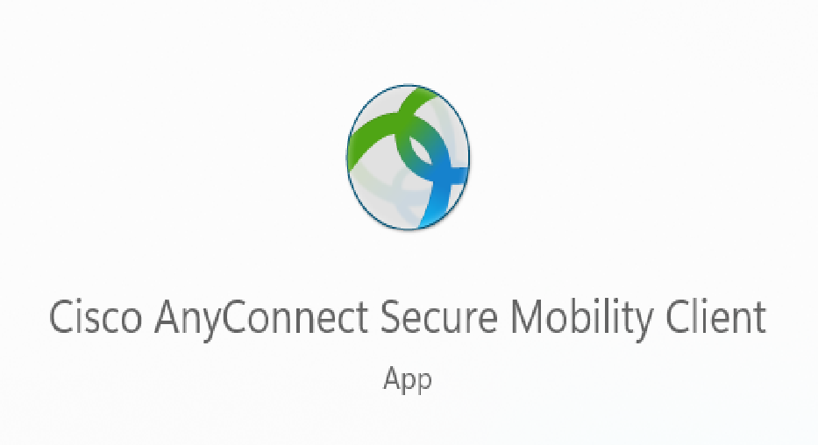

1. Once Received the Self-Service ID and Password from the IKEA Team that CGI.com. To activate the account the next step is the enrollment process. To proceed with that click on the self-service link that has been shared in the email. The imaged description is shown below for reference.

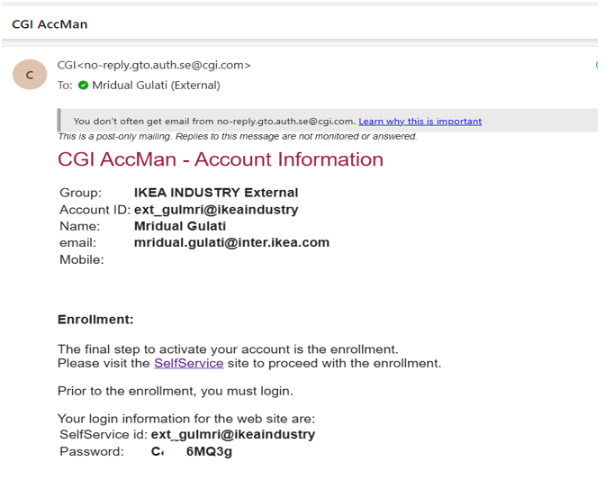

1. Once clicking on the Self-service link. Login to the CGI site as marked in the image below. Use the Self Service ID and password as received in the Email form CGI.

1. After login start the enrollment process choosing from the available authenticator options preferably **Microsoft authenticator** on your mobile device and continue.

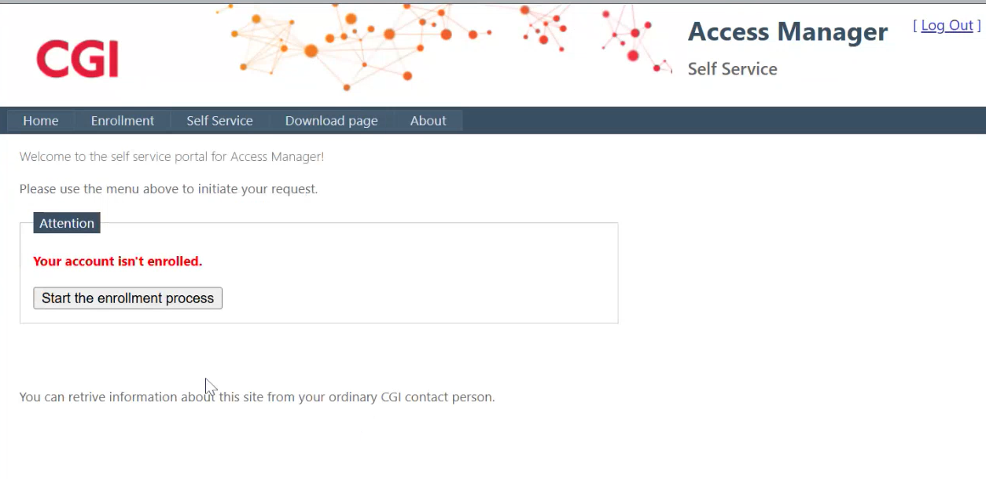

1. Create a Personal PIN code (PIN code can be of 4 digits) which will be used in combination with Authenticator code for the Password to connect the VPN.

1. Scan the barcode in Microsoft Authenticator app and CGI account will be created. Enter the onetime 6-digit code appeared on the CGI account in Microsoft Authenticator app on mobile device into the field shown in your system and verify. Once the verification is done. Click on continue to proceed further.

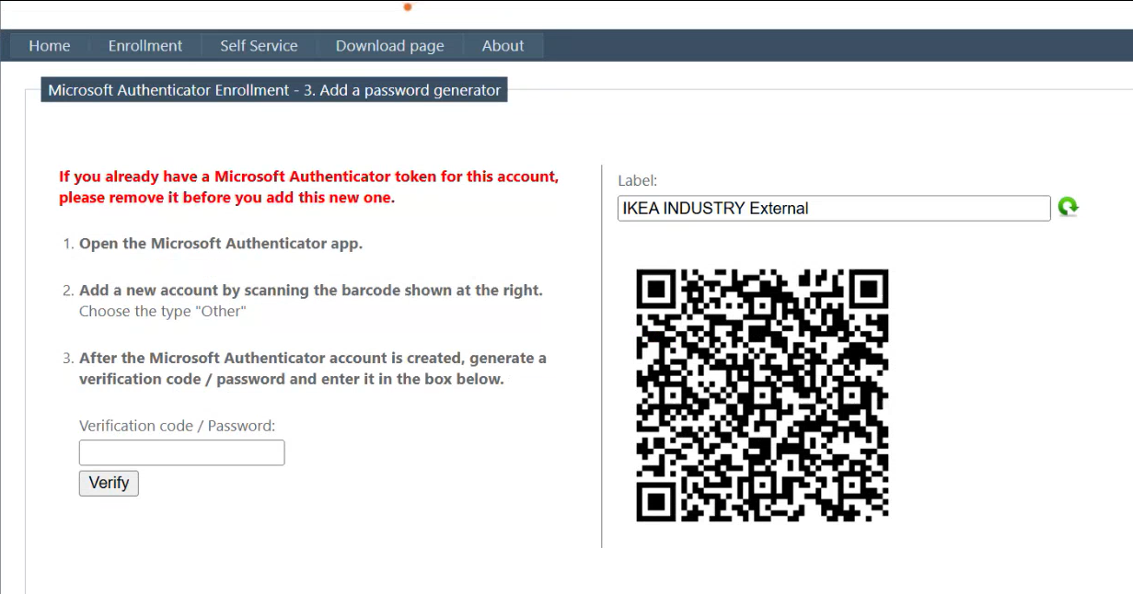

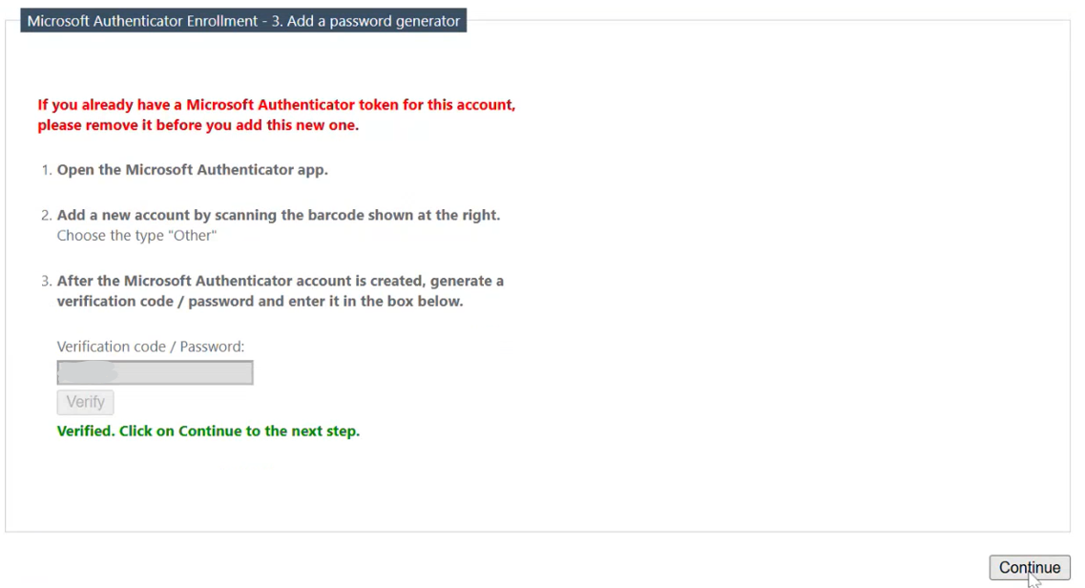

1. Now open Cisco AnyConnect in your system and enter the URL: **ra-eu.industry.ikea.com/externals** that appeared on the screen and click on connect as shown in the image below. It will ask for username and password to connect VPN.

For Username Enter **VPN Account ID** as shown in the page **ext_******@ikeaindustry**

For Password **Use combination** of **CGI account on mobile authenticator app** onetime **6-digit** code and **4-digit pin** that created earlier. That 10-digit code as password. VPN will be connected with this process.

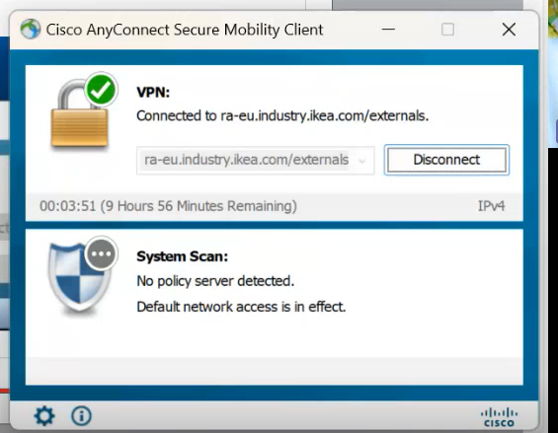

**Remote Desktop Connection**

1. For Remote Desktop connection for Lubawa Environment. Open Remote Desktop connection in your system. Enter **PLLUB-OW9002** in the field mentioned as computer and click on connect.

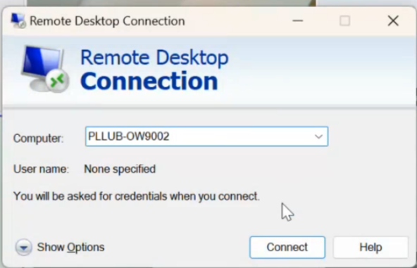

1. Use Email address as [**ext_******@swedwoodgroup.com**](mailto:ext_******@swedwoodgroup.com)and Password is your **IKEA Email account Password.**

1. Once login to Remote desktop account, select the SWEDWOODGROUP\popwal-adm.

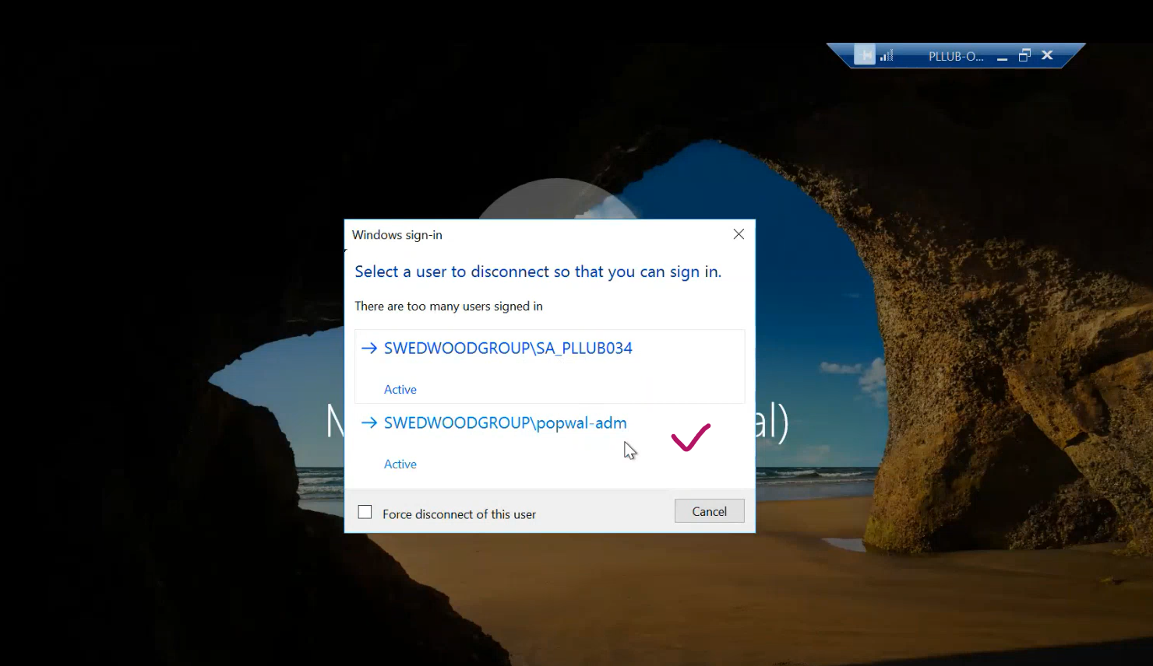

1. For Lubawa CM MES Environment. Enter the Url: [**https://pllub-oc9000.swedwoodgroup.com:8112/**](https://pllub-oc9000.swedwoodgroup.com:8112/)in Microsoft edge and enter.

1. Use Active Directory to login to CM MES Environment. Reference image is shown below.

Username (Enter Username without **@** address): **ext_\*\*\*\*\*\***

Password: **IKEA Account Password**

